21, rue d’Artois, F-75008 PARIS PSX-YY D2 Colloquium 2019
http://www.cigre.org

Paper title (Arial Bold 12)

N. AUTHOR¹, N. AUTHOR², N. AUTHOR³ (Times New Roman 12, Bold, Capitals)
Affiliation1¹, Affiliation2², Affiliation2³
Country 1¹, Country 2², Country 2³
SUMMARY (Times New Roman 12)
The paper starts with an extensive summary, of about 500 words, intended to provide readers with a thorough overview of the paper.
Summary and title give the first impression of a paper; hence great care should be taken in their formulation.
This template serves as an example of formatting s colloquium paper. Normal text is Times New Roman or Arial 11 or 12 and justified. This template uses Time New Roman 11.

KEYWORDS
Keyword 1 –Keyword 2 – Keyword 3 –Keyword 4 – Keyword 5

Heading 1 (Numbered, Times New roman 11, Bold)
Papers presented at a CIGRE Colloquium must be unpublished materials of strictly scientific or technical character, and not carry any advertising connotation. Consequently, the names of manufacturers must not appear in the body of the text, nor in tables or figures. Names of Companies or Universities should only appear at the top of the first page (title page), under the authors' names.

Structure of papers

Compulsory headings
For homogeneity, the paper structure with heading, “SUMMARY”, “KEYWORDS” and “BIBLIOGRAPHY” must be maintained. The titles “SUMMARY”, “KEYWORDS” and “BIBLIOGRAPHY” also must be kept as they stand.

Conclusions
In the conclusions, you should briefly present the results and their significance. If you have some recommendations, you can mention them. The advantages and limitations of the paper can be mentioned. In the conclusion chapter, you should conclude what you have done, not add any new things you have not written about previously.

Bibliography
Included at the end of the paper, the bibliography gives the details of the references mentioned in the paper. References should be mentioned following the order in which they appear in the text and they can be written as a cross reference like this: [1] or as a plain text like this [2]. Authors should not refer to internal company documents and more generally to any unpublished material.

Figures, Equations and Tables
Figures are centralised, followed by a figure text. Figures and tables should be self-explanatory. This means that the readers should understand the figure without reading the text, i.e. the title, axes, parameters, abbreviations, etc., should all be in the figure or in the figure text so that readers do not have to search these in the text before or after the figure.
Remember to use figures with sufficient quality, e.g. printable, clear and sufficient font sizes. Add a reference number also to figure text if the figure comes from a reference.
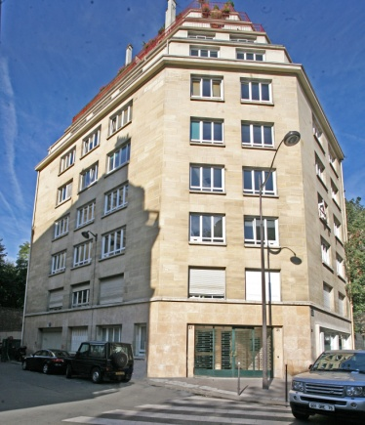
Figure 1: Figure text (Figure text style in Word, Times New roman 10, Bold, Centred)
An example of how to write equations is here. The relation between the maximum voltage and the effective voltage is:
 | $$U_{max}=\sqrt{2}U_{ rms}$$ | (3.1)
where U_{max} is for maximum voltage and U_{rms} is for effective voltage. Remember to italicise variables but not constants both in the text and in the equation. Equation (3.1) has two voltage variables and therefore U is italicised. Subscripts ‘max’ and ‘rms’ are not variables, so they are not in italics.
Table I: Table title (Table title style in Word, Times New roman 10, Bold, Centred)
Table text 2 | Value | Description
Table text

Bibliography
- Font to be used is always Times or Arial 11 or 12. In this template, Word Style is called ‘Subtle reference’, and the font is Times New Roman 11.
- First Name Last Name or Initial and Last Name. “Publication Title” Edition. Place and publisher, date. Series title (if applicable). Availability, access or location information (e.g. web link). Additional general information.
- M. Rausand, A. Høyland. “System Reliability Theory” (Second edition. USA, John Wiley & Sons, 2004. ISBN 0-471-47133-X.
- C.R. Heising, and R.J. Ringlee. “Prediction of Reliability and Availability of HVDC Valve and HVDC Terminal” IEEE Transactions on Power Apparatus and Systems, vol. PAS-89, No.4, April 1970, pp. 619–624. DOI: 10.1109/TPAS.1970.292608
- ENTSO-E Regional Group Nordic. “Nordic and Baltic HVDC Utilization and Availability Statistics 2016” Brussels, Belgium, ENTSO-E, 16 November 2017. [Online]. Available at: https://docstore.entsoe.eu/Documents/Publications/SOC/Nordic/HVAC2016.pdf

